NEWSLETTER
Term 3 Week 2

CATHOLIC CHARACTER NEWS

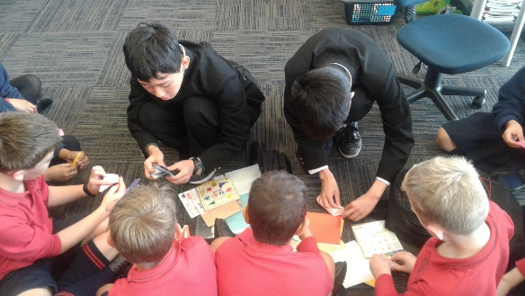
Japanese Students’ Visit
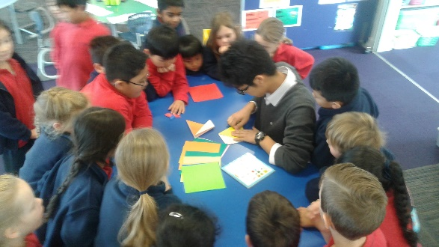
It was great to be able to welcome 20 students from Tokyo City University, Junior & Senior High School. They are visiting from Japan for three weeks and are staying with the families of students from Rosmini College. They kindly spent time with our students teaching them origami. Our students really enjoyed making cranes and jets. It was wonderful to see the learning that was happening with very little conversation occurring.
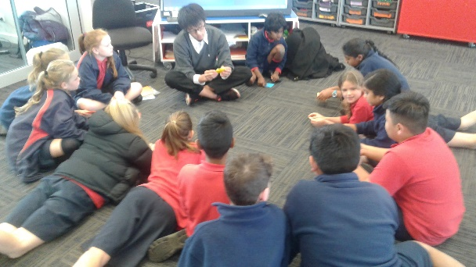
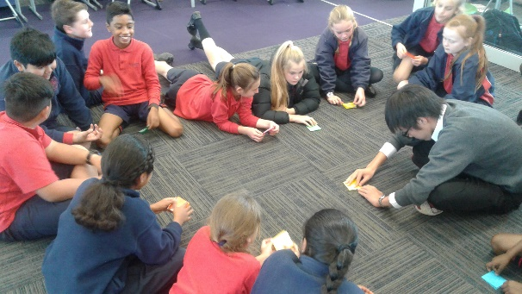

School Mass
You are welcome to join us for our School Mass on Friday 11 August. It begins at 9.15 and is in our St Joseph’s Parish Church. We encourage you to come along to this special occasion.

STUDENT REPORTERS

Rosmini Orchestra Visit
By Amelia L

On Thursday the 24 July 2017 the whole school walked over to Rosmini College to watch the Rosmini Orchestra perform in their auditorium. There were 7 brilliant performances which included a band, who played twice, a guitar band, a singer, a trumpeter, and a solo guitarist. The talented musicians were from years 12 and 13. Two were past pupils of St Joseph’s. Liam D’Souza sang for us and George Wilson played the saxophone and piano.

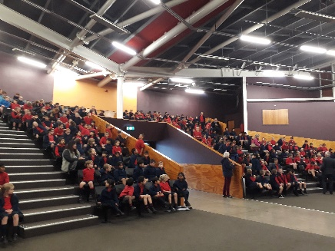
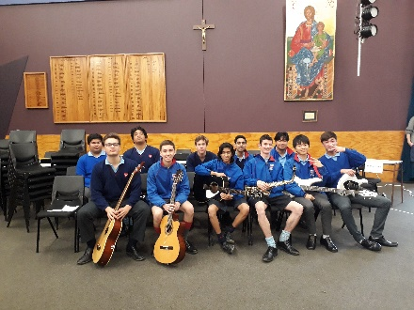
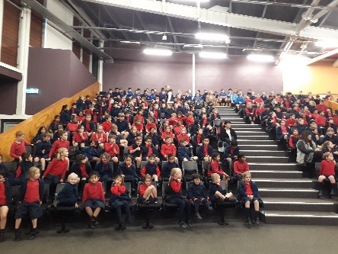

The host, in year 12, informed us about the up and coming school musical “Bugsy Malone”. We might know some of the cast as it is a joint production with Carmel College. We even had little peek at some of the set. The show runs from August the 9 to 11.

We had a lot of fun rocking out to the music of Rosmini College and we are hoping we could visit them again.

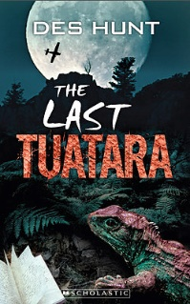
AWARD WINNING AUTHOR VISITS ST JOSEPH’S
By Ryan B and Daniel C

On Tuesday we had a very special guest come to St Joseph’s. New Zealand author Des Hunt came and spoke to the Kereru and Kakariki teams. Des Hunt has written a series of successful environmental adventures for 9-12 year olds.

Mr Hunt was born in Palmerston North during World War II, but spent his school years in Wellington. He considered a career working with animals but his parents were more keen on him teaching instead. For many years Mr Hunt taught Chemistry and Physics as well as Computer Electronics. He used his amazing science skills to demonstrate his successful formula for writing.

Des Hunt told us that the first book he wrote was called ‘The Last Tuatara’. He sent it to seven publishers, but got a rejection letter back from all of them. Des Hunt gave up writing for 3 years, but then he decided to publish twenty copies of the book himself. He was a teacher at the time and he gave some of his year 9 students the book and asked them to read it over the holidays. After the holidays, he asked who had read the book.

The room went quiet and only four people put their hands up. He was very annoyed and asked how many people had actually started reading the book. Everyone put their hands up. Then he realised there was a big problem with his book. Mr Hunt had written lots of nonfiction books in the past. The last Tuatara was a fiction book but, he was making it sound like a nonfiction one. He made many changes to ensure the book would have more appeal to the reader, again he sent the book to a publisher. Finally Scholastics accepted the book. Now Des has 20 books published and he said that if we give up we may never know just how successful we could be.

Our library has a number of Des Hunt books in it and after he had spoken we asked Des to sign our copies. The signed copies will be a very special part of our library collection.
Thank you Mr Hunt for visiting us, you made us laugh, you made us think, but most of all you have inspired us to all become better writers.

WEEK AHEAD

Term 3 Week 2 / 3
Thursday 3 August PTFA Meeting
Monday 7 July School Prayers
Tuesday 8 August Yr 5/6 Rosmini Bugsy Malone Show

GENERAL

Traffic Management
We are re introducing the requirement that cars that arrive before 2.55pm are to park. The gate entry for drive by pickup will be opened at approximately 2.55pm. This is to ease the congestion that is occurring on Taharoto Rd and Dominion St. Once you have parked your car, please collect your child from the pickup area or from the quad. Please can you let the person who collects your child know of this return to parking before 2.55pm.

Your child is not allowed to walk to your parked vehicle , unless they are with an adult.

There are 50 marked parks available on the court area and there are approximately 75 parks in the parish parking area. If you wish to do a drive by pickup, I recommend you arrive after 3pm.

God bless
Alister Bridgman
Principal

