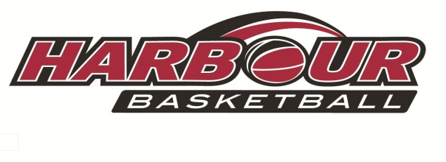

Harbour October Holiday
Basketball Camp 2019
Camp 1:
***Mon 30th Sept, Tues 1st Oct***
Camp 2:
***Mon 7th Oct, Tues 8th Oct***

-With Special Guest Coach-
Kevin Braswell
Eventfinda Stadium( formerly NSEC)
Silverfield Lane , Glenfield
Camp 2 will also host alongside……
Girls Only Basketball Skills Camp
Coached by Tall Ferns Assistant Coach, Jody Cameron
With the assistance of our Harbour Breeze Reps
Come along for fun, games and update your skills.
In conjunction with BBNZ Girls Got Game Programme

Time: 9.00am - 3.00pm Doors open at 8.30am
Open to all Boys and Girls Aged 8-14

Cost for Camps: $130 for two days
Cost to attend both Camps: $250.00 (4 days)
Register now through the Harbour Basketball Website

