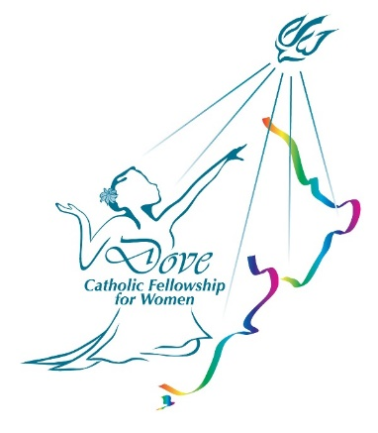

**DOVE FELLOWSHIP FOR WOMEN WILL MEET ON WEDNESDAY, 19th AUGUST 2020, 7:30 P.M.**

**AT ST. THOMAS MORE CATHOLIC CHURCH,**

**336 WAIRAU ROAD, GLENFIELD.**

**FR. ALFREDO GARCIA WILL SPEAK ON THE TOPIC “SWORD OF THE SPIRIT” (LECTIO DIVINA).**

**COME, MEET AND FELLOWSHIP WITH**

**OTHER WOMEN FROM THE NORTH SHORE.**

**For info please contact Sylvia 021 08822990**