M Sports Rugby Kidz Skills Clinics at St Joseph’s School

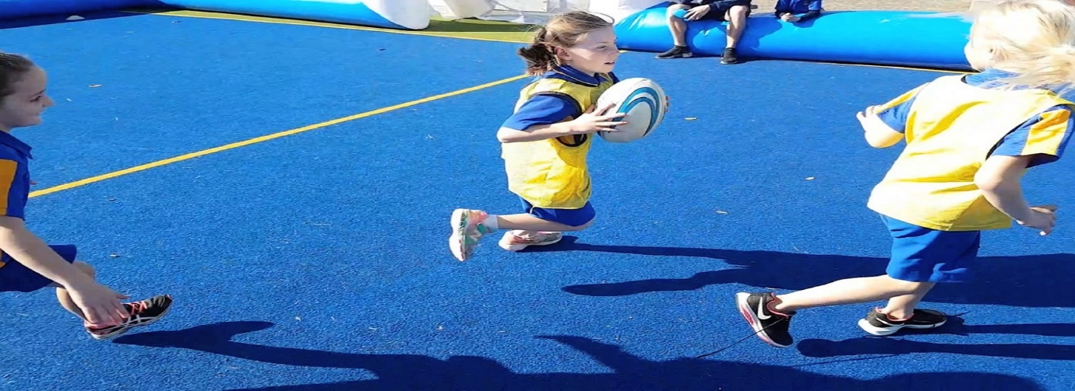
M Sports are coming back to hold fun Rugby Kidz clinics at the school. Girls and boys from years 0-6 are welcome to participate. They'll play fun games, learn exciting new skill techniques, play small matches and make new friends all under the guidance of our great team of qualified coaches.
When: 5 weekly sessions starting Friday 14th August
Time: Lunch
Where: School Field
Cost: $49 per child, $24 per extra sibling
Register on enrolmy.com/msports-northshore. For more info please email Chris on adminnorthshore@msports.co.nz

