M Sports Football Kidz Skills Clinics at St Joseph’s School

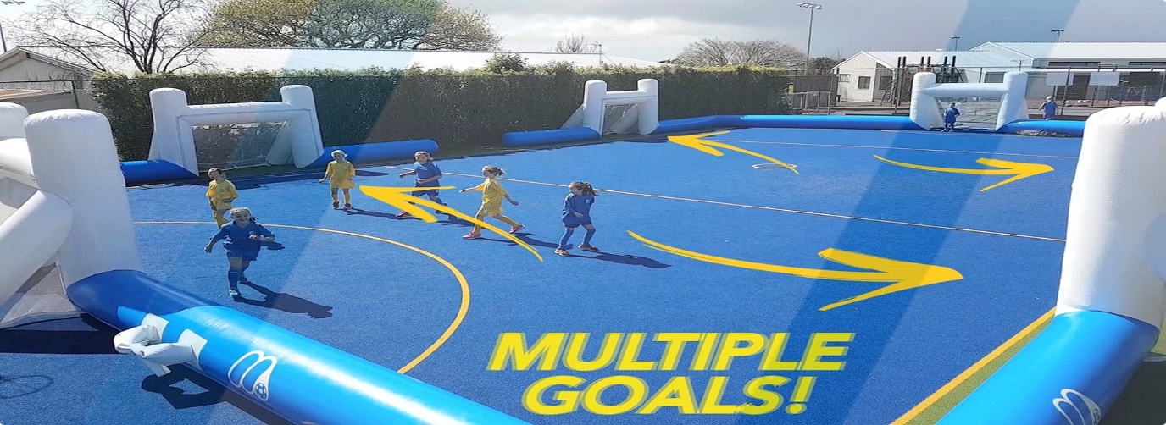
M Sports are coming back to hold fun Football Kidz clinics at the school with our new inflatable pitch. Girls and boys from years 0-6 are welcome to participate. They'll play fun games, learn exciting new skill techniques, play small matches and make new friends all under the guidance of our great team of qualified coaches.
When: 5 weekly sessions starting Monday 30th May
Time: Lunch
Where: School Field
Cost: $64 per child, $32 per extra sibling
Register on enrolmy.com/msports-northshore. For more info please email Chris on adminnorthshore@msports.co.nz

