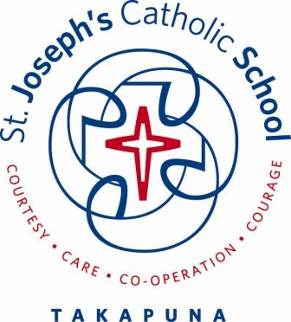

School Vision and Hearing Testing
2022

Waitemata District Health Board provides free visions and hearing screening for children. This screening is carried out by Vision and Hearing Technicians who visit schools and provide Vision and Hearing in various community locations.

Vision Test

Distance Vision: A letter matching (or letter identifying) test determines whether the child can see what is expected at 4 metres distance

Hearing Test

Audiometry: An audiometer is used to measure hearing. The child wears headphones, and drops a peg/bead into a basket every time a sound is heard.
Tympanometry: If the child does not seem to hear all the sounds with the audiometer test, the tympanometry is used to show whether there may be ‘glue ear’ or some other blockage in the hearing system. A soft rubber cap seals the opening of the ear and a measurement is made of how well the eardrum reacts to sound and changes of air pressure.

Parents/caregivers will be informed of all the results (including any problems identified)
If your child does not pass a vision or hearing screening test, you will receive a letter suggesting what to do, including a follow up.

Student Name: ………………………………………………………………………………….. NHI Number: …………………

Date of Birth: ………./………./……….. Ethnicity ………………………………………………………………………………

School: St Joseph's Catholic School Takapuna

Student Address:................................................................................................................................................................

…………………………………………………………………Caregiver Mobile/Phone Number: ………………………………

Family Doctor (GP) ………………………………………………………………………………………………………………..

I consent to vision and hearing testing for my child at school

Vision Test Yes …. No …. Comment ……………………………………………………………………………..

Parent / Guardian Name ………………………………………………………………………………………………

Parent / Guardian Signature ………………………………………………………………………………………….

The result of the screening will be stored in the Ministry of Education ENROL database. Any information on this database can only be accessed by properly authorised school personnel or Vision and Hearing Technicians. If your child passed the vision and hearing test at age 4 (part of B4 School Check), no further testing may be needed at school.

