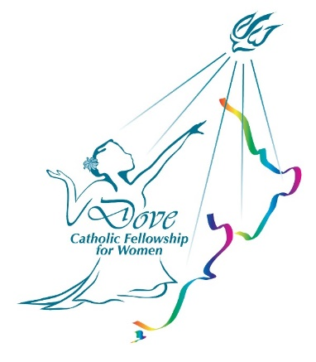

**DOVE FELLOWSHIP FOR WOMEN**

**SHARED DINNER WED. 16th NOV, at 6 P.M. AT ST. THOMAS MORE CATHOLIC CHURCH HALL, 336 WAIRAU ROAD, GLENFIELD.**

**TOPIC:** ADORNED WITH THE OIL OF GLADNESS

**Scripture**: **PSALM 45: 7 - 9**

**SPEAKER: CHRISTINE KORNMAN (from Hamilton)**

**MUSIC: WILMA CONROY (from Hamilton)**

**COME DRESSED IN YOUR BEST AND FELLOWSHIP with WOMEN FROM THE NORTH SHORE.**

**For info please contact Sylvia 021 088 22990**