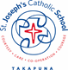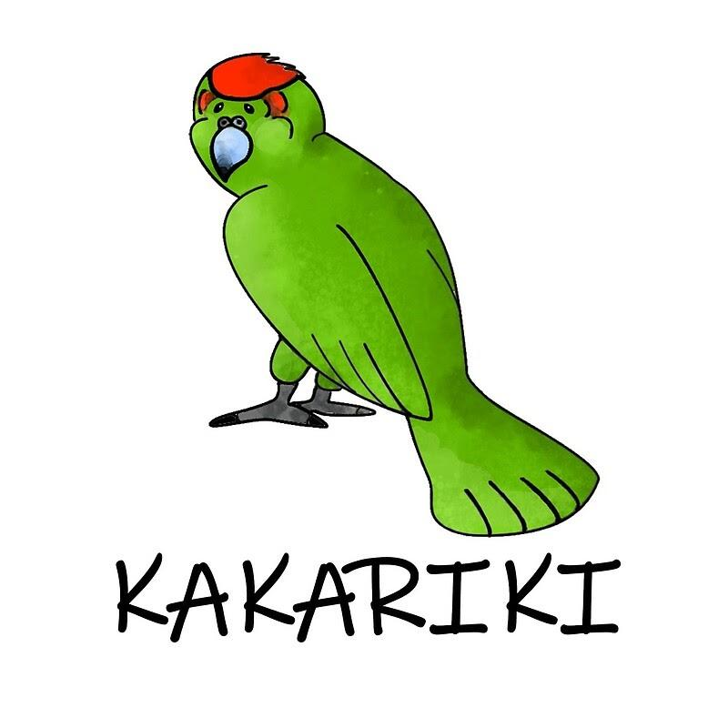

Wednesday 26 April 2023 Kakariki Team Newsletter - Term 2, 2023

Dear Parents and Caregivers,

Welcome back for another action packed term in the Kakariki Team. We have lots of awesome things that are happening this term and there will be plenty of opportunities for the students to work with different teachers and students across our pods and teams.

Important Dates for the Kakariki Team - subject to change

Mondays: Library sessions - please encourage children to return their books each week.

Week 1: 24-28 April  Mon: Teacher Only Day  Tues: ANZAC Day  Wed: HG2, HG5 & half of HG3 to Tiritiri Matangi  Thurs: HG1, HG4 & half of HG3 to Tiritiri Matangi | Week 2: 1-5 May  Mon: St Joseph’s Day Mass 9:15am  St Joe’s Got Talent 11am  Tues: Waterwise sessions - HG1 morn & HG5 arvo  Tues: North Shore Swim Comp.  Wed: MSports Rugby Promo | Week 3: 8-12 May  Tues: Waterwise sessions - HG4 morn & HG3 arvo  Wed: Rosmini Open Day 1:30-3pm (parents take Year 6 boys) | Week 4: 15-19 May  Tues: Waterwise sessions - HG2 morn & HG1 arvo  Thurs: Feast of the Assumption - Team Prayers  Fri: Class Photos  Fri: Mercy Values Day | Week 5: 22-26 May  Tues: Waterwise sessions - Saver Day  Thurs: Rippa Rugby Tournament
Week 6: 29 May - 2 June  No extra dates | Week 7: 5-9 June  Mon: King’s Birthday | Week 8: 12-16 June  Sharing the Learning Week - date & time TBC | Week 9: 19-23 June  Wed: Year 6 Netball field day | Week 10: 26-30 June  Fri: YCC Day  Term 2 ends 2.50pm

Home Learning

Home Learning Challenges: Continue to encourage your child to complete at least two of these challenges per term. | Reading: Students read their own books for a minimum of 20 minutes each day, including weekends.
Spelling: The children have online activities on StepsWeb to support their learning in this area. This includes student words lists (approx 30 mins across the week). | Maths: Mathletics is used to support the strategies that the children are working on at school. They can also work on number facts and tables at homes (approx 30 mins across the week).

Kakariki Learning Term 2

RE  Our strands for this term are the Holy Spirit Strand including Ascension Thursday and Pentecost. We then move into looking at the God Strand.  Languages  Te Reo and tikanga will be integrated into our programmes throughout the term, as well as being used in our daily greetings and commands. | Inquiry  Inquiry enables students to learn through curiosity, discovery, and collaboration. When planning these units, we look at cross-curricular links so the children can consolidate their understanding in different areas.  Some units that we will cover this term are:  ANZAC Day, Tiritiri Matangi & the Young Ocean Explorers Challenge - looking at Kaitiakitanga and how we can protect our environment for future generations. We will also be learning about Bishop Pompallier and his contributions to the early church and bringing Catholicism to NZ.
Literacy  We will cover a range of text types over the term based around our inquiry topics.  The texts will be differentiated to cater for different learners in our classes and the children will have an element of choice with their follow-up tasks.  We will begin with exploring non-fiction text types and looking at the different features of writing non-chronological reports.  Spelling is part of the weekly Literacy programme. We will be using a programme called The Code and Steps Web to support the teaching and learning programme in this area. | Maths  Weeks 1 - 5: Multiplication & Division  - Times table blitz to ensure that children are able to promptly recall their times table and division facts.  - Explore different multiplication and division strategies to solve a range of problems.  Weeks 6-10: Proportions & Ratios  - Work through a range of problems related to proportions and ratio.  - Practice their knowledge and strategies in this area.  Strand focus: Finishing off Measurement: Length, time, area, volume, mass and capacity.  Exploring Geometry: Shape, Position and Orientation and Transformation.
The Arts  Drama - drama opportunities will be included in the units of inquiry topics where possible.  Visual Art - exploring different art techniques and materials relating to the different units of inquiry. | PE  Waterwise: In Term 2, each class will have their 2nd session at Lake Pupuke, with a focus on increasing their confidence in the water, sailing an optimist and developing their kayaking skills.  Cooperative games in Home Groups, pods and teams

Learning is a partnership between home and school. Please let us know if there is anything that we can do to support you and your family with your child’s learning. Your first point of contact is your child’s teacher, followed by Miss Bateman.

Important Dates for Term 3 - EOTC Week: Wednesday 13th - Friday 15th September

Year 6 Camp: This will take place at Carey Park Camp in Henderson. The aim of this camp is for students to experience learning outside the classroom, take risks, challenge themselves, learn new skills, show teamwork and support others. More information will be sent home shortly.

Year 5 EOTC Programme: While the Year 6’s are at camp, the Year 5’s will have their own outdoor education programme.

Kind regards

The Kakariki Teachers
Ms Ingrid Young, Mr Stephen Rae, Miss Nellie Chapman, Miss Laura Bateman, Ms Francisca Knottenbelt and Mr Peter O’Connor

